THE NEW RESIDENCE GOLF ACADEMY!
We are pleased to announce the opening of the Residence Golf Academy in Gammarth. Our exceptional training facilities are open to all ages and you do not need to be a member of the Golf Course in order to begin your training OR to take your game to the next level.

WHO CAN BENEFIT?
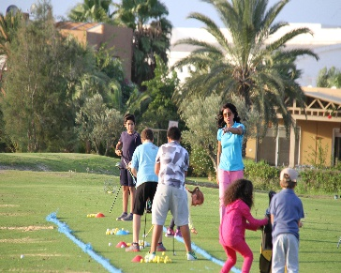
- Our Center helps children (ages 5 to 18) to discover the golf benefits of physical conditioning, technical skills, and mental focus. Training is open every Wednesday and Saturday.
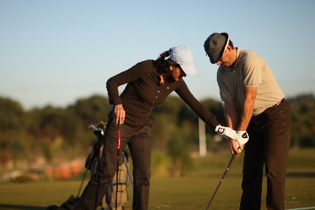
- Adults can take individual or group lessons. Our training is structured to start the new golfer on the correct swing path, or to make adjustments to the experienced golfer’s game in order to take it to the next level.
- Team building programs can be arranged for corporate events/orientation as well as challenge competitions such as for putting and chipping.

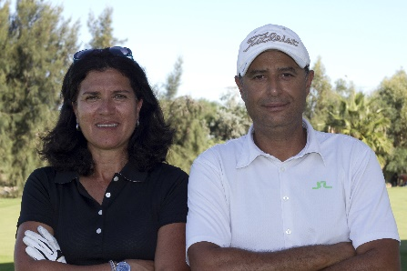
FACILITIES: Our first-rate training center has superbly maintained and manicured practice greens, sand traps, chipping and pitching areas, and of course, a driving range. We will also be offering the latest swing analysis equipment to help you insure the most correct swing path. Don’t let your demanding work schedule interfere because we can give night instruction in our well-lighted facilities.

OUR INSTRUCTORS: Both professional golfers and certified instructors (Lily and Chokri) have many years of experience. If you wish to have a background information sheet on their experience, just e-mail the address below and it will be provided to you. References are also available for both instructors if desired.

WHAT NEXT: For more information you can call: 22 361 171 / 28 389 046
OR e-mail: golfacademygammarth@gmail.com

SPECIAL OFFER: Just ask for a 30-minute introductory lesson/evaluation by contacting us at the above phone number.

About me on the Web:
https://www.facebook.com/lmaaref?fref=pb&hc_location=friends_tab
http://www.lindigo-mag.com/La-Tunisie-sera-presente-au-Salon-du-Golf-_a824.html
http://www.golfcitrus.com/page.php?id=36&lg=fr
http://news-ontt-france.over-blog.com/2016/02/la-tunisie-vous-donne-rendez-vous-a-la-10eme-edition-du-salon-du-golf-de-paris-du-18-au-20-mars-2016-porte-de-versailles.html
http://www.classtourisme.com/La-Tunisie-au-Salon-du-golf_a1116.html
http://www.telegraph.co.uk/sport/golf/3005073/Ladies-British-Masters-Last-years-tournament.html
http://www.golftoday.co.uk/news/yeartodate/news00/ladiesitalianopen.html
http://www.golfsweden.com/golftavlingar/gsarkiv2000/letorderofmerit27082000.shtml
http://www.golfsweden.com/golftavlingar/gsarkiv2000/ladiesfranceopen.shtml
http://www.turess.com/fr/letemps/5712
http://www.lequotidien.tn/49201-tunisie-sports-lancement-dune-equipe-feminine.html
https://nl.wikipedia.org/wiki/Dutch_Ladies_Open_2010
http://www.tunisia-today.com/archives/19800

IGS est à votre service pour une bonne partie !
www.internationalgolfservices.com

